Uni3 - Application for Photo & Filming

The form below must be completed and sent to Uni3 Security at security@uni3bygeely.com at least five working days before the date the application applies to.
If the application is approved, you will receive a signed form in return.
You must present the form bearing Uni3 Security’s signature at the Front Desk.
You must follow the guidelines below:
- When filming and photographing be mindful not to include people or organisations/brands without their permission.
- Any film/photo crew needs to be accompanied by someone in an organisation that resides at Uni3 in their responsibility.
- If drones are used you need to be able to provide appropriate certificates, as there are several protected areas and objects around Uni3. Read more here: Dissemination Permit | Lantmäteriet & here: Drones – unmanned aircraft - Transportstyrelsen. We would also like to remind you that we have drone footage of the campus which you are free to use, we also have professional images of Uni3 inside and out. Please contact malin.willbro@gshab.com for any questions or requests on this.
- Uni3 reserves the right to withdraw the approval if the designated area becomes unavailable due to events or conference bookings.
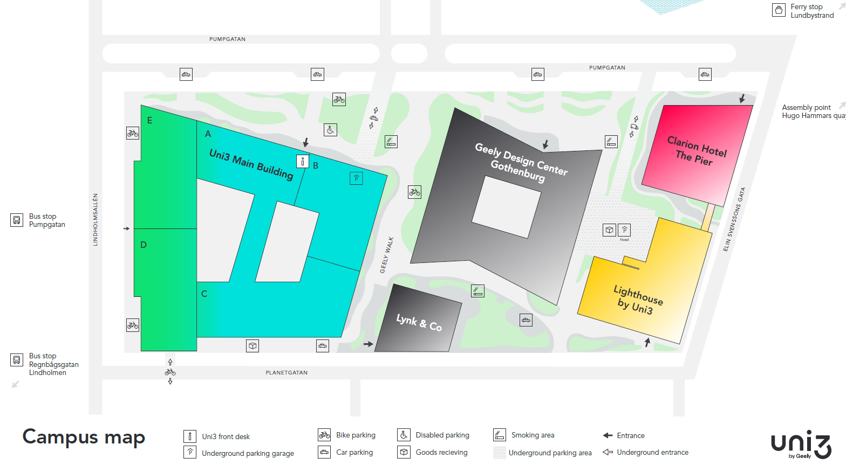

Company name: _________________
Name of responsible on site: _____________________
E-mail: _____________________
Phone number: _____________________
Amount of people in filming crew: _____________________
Area: _____________________
Date: _____________________
Time: _____________________
Purpose: _____________________
Type of activity:
☐ Photography ☐ Filming ☐ Both
Type of equipment:
☐ Drone ☐ Camera ☐ Both

Additional information: _____________________

Approved by Uni3 Security:
Date | Name | Signatue
2026-05-29

